SCCM LAB Environment test

Attempt to create an SCCM lab environment in Azure -

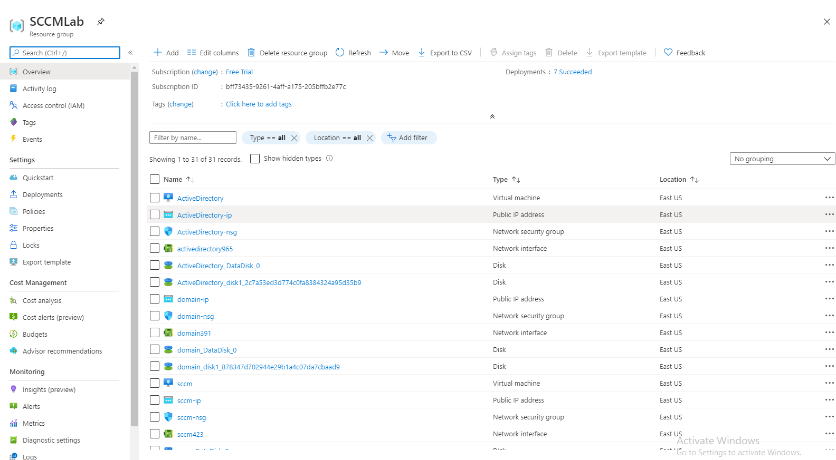

Attempt to make SCCM lab environment in Hyper-V

